How far can you get without relativity?
Jan & Ottmar Kechel, August 2017
theory@kechel.de

Abstract 1
Experiments 1
Basic experiments 1
Experiments leading to relativity 2
Explanations for astrophysical effects 2
Atom 2
Explanation 2
Unifying Lorentz force and Magnetism 3
The resulting force on a single particle 3
How and when to apply? 4
Conclusion 4
Our Claims 4
No magic involved 4
Basics of this theory 5
Further information 5

Abstract
In our personal experience several physical effects that are not easily explained with classical theories are simply ‘explained’ by telling that you’d need to resort to relativity as explanation.
This paper tries to fill this gap by thoroughly explaining and calculating the correct result of such experiments without resorting to relativity.

Experiments

Basic experiments
We are analysing a bunch of basic experiments:
- Bar magnets
- Electron deflection
- Forces on current carrying conductors
- Parallel electron beams
- Skin effect
.. all of which we succeeded to explain without relativity.

Experiments leading to relativity
We also analysed a bunch of experiments that once led to the theory of relativity:
- De Sitter double star observation
- Michelson-Morley
- Sagnac effect
- Synchrocyclotron
- Tunneling of EM waves through prism slit
- Wave-particle duality
.. all of which we succeeded to explain without relativity.

Explanations for astrophysical effects
We seem to have possible explanations for several astrophysical observations:
- Pulsars
- Jets
- Size of the (observable) universe
- Gravitational bending of light
- Apsidal precession
- RF resonant cavity thruster

Atom
The atom nowadays is seen as a complex thing, and most calculations are based on wave-functions.
But, as soon as we applied our findings to the plain old Bohr atomic model, this suddenly makes a lot of sense, meaning that you can derive and/or calculate the following things:
- electron radius
- electron energy levels
- frequencies of emitted light are exactly the same as the orbital frequencies
- mass of photon
- conservation of energy
- conservation of momentum
- conservation of angular momentum

Explanation
All these experiments can be explained with a simple, but thorough, application of two well known effects:
The Lorentz force and Magnetism

All we did is to calculate the direct force between relatively moved charged particles as a result of:

- each moved charged particle creates a magnetic field around it
- each moving and charged particle within a magnetic field experiences the lorentz force

Unifying Lorentz force and Magnetism
The resulting formula, to calculate the force between two particles, solely based on their charges, distance and relative speeds looks like this:
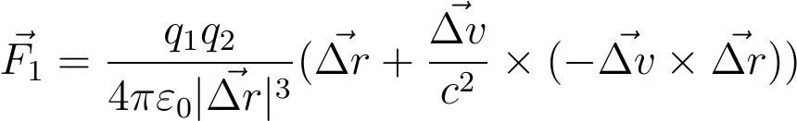

But this is nothing new, it’s simply the combined equations for magnetic force and the Lorentz force together. Here you can view the complete derivation online or downloadable as PDF.

The practical problem with this solution is, that if you want to calculate something, you can’t simply go with summarizations like currents or magnetic fields. These are all only aggregations and abstractions for lots of involved particles as a whole. Instead you have to calculate the resulting force on each particle with above formula as sum of the resulting forces of each other relatively moved particle. This is also the most probable explanation why this hasn’t been done a hundred years ago but only now could become feasible through the availability of computational power.

The resulting force on a single particle

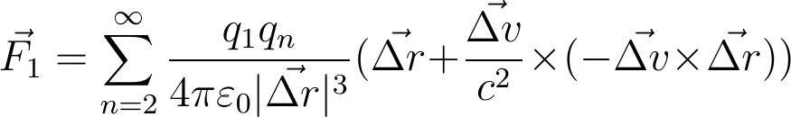

where

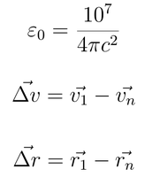
Here you can view the complete derivation online or downloadable as PDF.

This is it, there is nothing more to this theory which does not derived from plain old classical physics. No magic involved.

How and when to apply?
There are lots of very useful abstractions, like magnetic fields or wave-patterns for atoms, which are correct for lots of overall calculations. But just like the abstraction of a trafficjam with 20 minutes delay, which serves perfectly to get an overall picture as well as calculating the average speed, this abstraction does not deliver any information about the speed of individual cars at specific points in time.
If you want to explain or calculate things where either the abstraction is based on incorrect or incomplete assumptions (as e.g. possibly in complex magnetic fields like fusion reactors) or you want to calculate individual particles, as opposed to the average of all particles, then this is the way to go. Additionally there are lots of effects that simply can’t be explained solely on the abstraction level at all, or at least correct for incomplete assumptions in complex scenarios.

Conclusion
Well, our conclusion is, that a unified theory of the universe doesn’t need relativity at all.
What else can be explained? Which experiments still need relativity to be explained? We are curious for feedback, but please first consider the ‘whole’ theory:

Our Claims
- all commonly known experiments for relativity can also be explained with this theory (see the section Experiments & Observations)
- lots of observations that couldn't be explained with relativity can be explained with this theory
- this includes entanglement as well as effects today thought to be caused by dark energy and dark matter
- no violations of the laws of physics
- there is the chance to come to a unified theory of physics with quantum mechanics
- electromagnetic waves, electric near-fields, magnetic near-fields, and free electrons influence each other and with that the universe way more than formerly thought

No magic involved
- no limit of velocity for matter or light
- no relativity of time
- no simultaneity loss in different inertial systems
- no relativistic mass increase
- no length contraction depending on velocity
- no ether
- no god, no string, no parallel universe or higher power
- no magic

Basics of this theory
- causality is given for all physical effects
- conservation of energy
- conservation of electric charges
- Newton´s third law is valid without any limitation,
- the reaction is immediate, there is no time retardation for forces
- (in todays physics quasistatic electric and quasistatic magnetic forces act with time retardation)
- everything can fly at any velocity (no limit at the speed of light)
- light propagates at the speed of light relative to its origin (in compliance with the emission theory)
- there is no mass-increase, no length contraction, and no time dilation no matter at which velocity
- electric near-fields, magnetic near-fields and gravity are immediate (there is no transmission speed)
- electric near-fields, magnetic near-fields and gravity-fields (the fields itself) do not contain energy
- the light cylinder is only valid for energy carrying electromagnetic fields, it does not limit the quasistatic electric and magnetic fields
- antennas should be measured with not only one but three parameters: sensitivity for electromagnetic-waves, sensitivity for quasistatic magnetic fields, and sensitivity for quasistatic electric fields (of course each one depending on frequency)

Further information
- Homepage: http://theory.kechel.de/
- Downloadable copy of Homepage: http://theory.kechel.de/attachment/0/20170311-theory.kechel.de.tar.bz2
- Mirror of Downloadable copy of Homepage: https://github.com/kechel/ParticleMovementSimulator/blob/master/doc/20170113-theory.kechel.de.tar.bz2
- Unifying Lorentz force and Magnetism: http://theory.kechel.de/attachment/462/kechel_unified_magnetism_and_lorentz_force_V3.pdf?download=true
- Derivation of the formula: http://theory.kechel.de/attachment/462/Dyn_Force_Math_V4_20170203.pdf?download=true
- Mirror of our documents as well as particle movement simulators: https://github.com/kechel/ParticleMovementSimulator/tree/master/doc

